USER REGISTRATION SIGN IN CODE :

<!DOCTYPE html>

<html lang="en">

<head>

<meta charset="UTF-8">

<meta http-equiv="X-UA-Compatible" content="IE=edge">

<meta name="viewport" content="width=device-width, initial-scale=1.0">

<title>Document</title>

<!-- CSS only -->

<link href="https://cdn.jsdelivr.net/npm/bootstrap@5.2.2/dist/css/bootstrap.min.css" rel="stylesheet" integrity="sha384-Zenh87qX5JnK2Jl0vWa8Ck2rdkQ2Bzep5IDxbcnCeuOxjzrPF/et3URy9Bv1WTRi" crossorigin="anonymous">

<!-- JavaScript Bundle with Popper -->

<script src="https://cdn.jsdelivr.net/npm/bootstrap@5.2.2/dist/js/bootstrap.bundle.min.js" integrity="sha384-OERcA2EqjJCMA+/3y+gxIOqMEjwtxJY7qPCqsdltbNJuaOe923+mo//f6V8Qbsw3" crossorigin="anonymous"></script>

</head>

<body>

<form action="/hr/signin" class="container" method="post">

<label for="">Email</label>

<br />

<input type="email" class="form-control" name="email" placeholder="Enter your Email.." required />

<br />

<label for="">Password</label>

<br />

<input type="password" name="password" class="form-control" placeholder="Enter your Password" required />

<br />

<input type="checkbox" name="" id="" required />

<label for="">Check the box</label>

<br />

<br />

<button type="submit" class="btn btn-success">Sign-In</button>

</form>

</body>

</html>

OUTPUT:

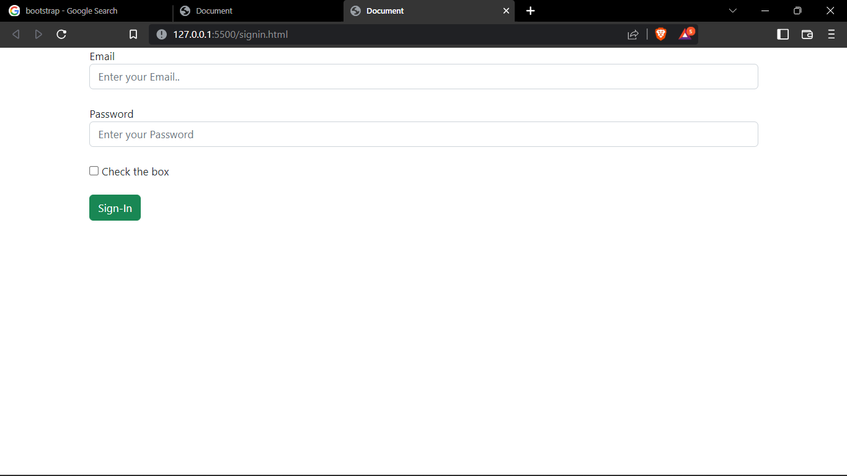

USER REGISTRATION SIGN UP CODE:

<!DOCTYPE html>

<html lang="en">

<head>

<meta charset="UTF-8">

<meta http-equiv="X-UA-Compatible" content="IE=edge">

<meta name="viewport" content="width=device-width, initial-scale=1.0">

<title>Document</title>

</head>

<!-- CSS only -->

<link href="https://cdn.jsdelivr.net/npm/bootstrap@5.2.2/dist/css/bootstrap.min.css" rel="stylesheet" integrity="sha384-Zenh87qX5JnK2Jl0vWa8Ck2rdkQ2Bzep5IDxbcnCeuOxjzrPF/et3URy9Bv1WTRi" crossorigin="anonymous">

<!-- JavaScript Bundle with Popper -->

<script src="https://cdn.jsdelivr.net/npm/bootstrap@5.2.2/dist/js/bootstrap.bundle.min.js" integrity="sha384-OERcA2EqjJCMA+/3y+gxIOqMEjwtxJY7qPCqsdltbNJuaOe923+mo//f6V8Qbsw3" crossorigin="anonymous"></script>

<body>

<form action="/hr/signup" class="container" method="post">

<label for="">Name</label>

<input type="text" class="form-control" placeholder="Enter Your Name" required name="name">

<br>

<label for="">Email</label>

<input type="email" class="form-control" placeholder="Enter Your Email" required name="email">

<br>

<label for="">Phone</label>

<input type="number" class="form-control" placeholder="Enter Your Phone Number" required name="phone">

<br>

<label for="">Password</label>

<input type="password" class="form-control" placeholder="Enter Your password" required name="password">

<br>

<label for="">Confirm Password</label>

<input type="password" class="form-control" placeholder="Confirm Password" required name="re-password">

<br>

<label for="">Verify</label>

<input type="checkbox">

<br>

<br>

<button class="btn btn-danger" type="submit">Sign-Up</button>

<br>

<br>

</form>

</body>

</html>

OUTPUT:

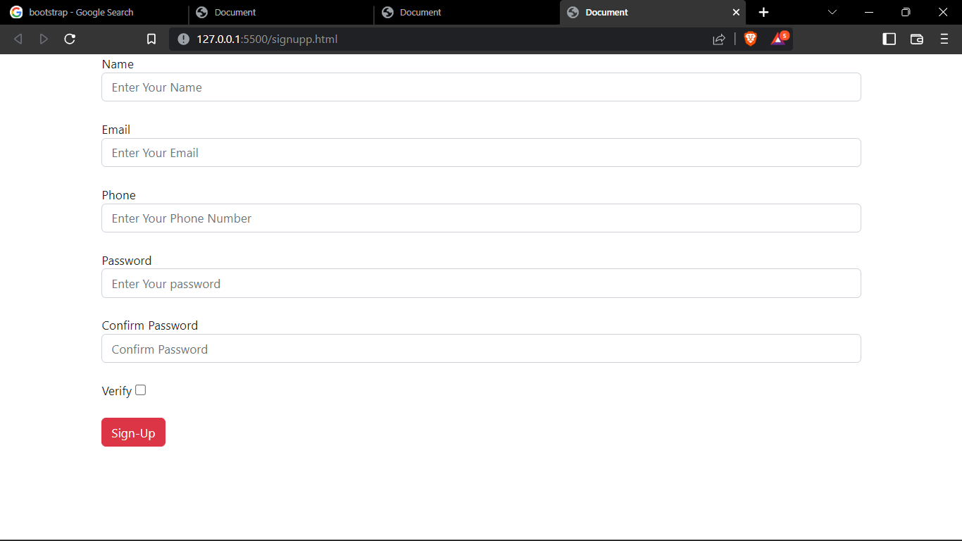

PYTHON CODE :

import random as rand

print("WELCOME SMART FARMER")

temperature = float(rand.uniform(15,50))

if(temperature>22 and temperature<40):

humidity = int(rand.randint(45,65))

elif(temperature<22):

humidity = int(rand.randint(60,70))

elif(temperature>40):

humidity = int(rand.randint(25,35))

moisture = int(rand.randint(00,70))

print("temperature:",temperature,"C","\n","humidity:",humidity,"\n","moisture:",moisture)

if(temperature>35 or moisture<20 ):

print("Irrigation required")

print("Activate irrigation ?")

decision = input()

if(decision == 'yes'):

print("Irrigation activated")

else:

print('Irrigation not activated')

else:

print("Irrigation not required")

OUTPUT:

